Software Requirements Specification (SRS)
Investment Portfolio Simulator
Unit | CPRO306 Capstone Project
Assessment | Assessment Brief 2: SRS Report
Prepared by | [Insert names of all 5 group members]
Group size | 5 members
Prepared for | [Insert lecturer name]
Submission date | [Insert date]

This report presents the requirements, system design, database structure, privacy controls, user interface design, testing plan, and project schedule for the proposed Investment Portfolio Simulator. It is prepared in line with the project proposal and the assessment brief for Assessment 2.

1. Introduction

1.1 Purpose of the report
This document defines the software requirements and design direction for the Investment Portfolio Simulator. It explains what the system is expected to do, the business and technical conditions that shape the solution, and the way the project will be developed, tested, and presented. The SRS is intended to guide the team during implementation and to show that the proposed system has been analysed in a structured and professional way.

1.2 Background
The project proposal identifies a need for an educational fintech system that helps beginner users understand investment activity without the risk of losing real money. Many first-time investors understand the basic theory of buying and selling but have limited confidence when making decisions with real funds. A simulator reduces that barrier by allowing users to practise trading, monitor portfolio performance, and learn from outcomes in a safe environment. This purpose is consistent with recent findings that digital financial literacy remains uneven and that many adults still struggle with important digital finance behaviours (OECD, 2023).

1.3 Scope
The system is a web-based full-stack application that allows registered users to create and manage an account, maintain a virtual investment portfolio, simulate asset trades, view portfolio analytics, and review transaction history. The system may use simulated or historical market data to support learning. Real brokerage integration, live money transfers, automated trading, and personalised investment advice are outside the project scope.

2. Project Description

2.1 Business description
The proposed system sits in the educational financial technology domain. Its value is not in replacing a real trading platform but in simplifying investment concepts and turning them into a practical learning experience. Instead of reading market theory only, users can interact with prices, holdings, balances, and charts to understand how portfolio decisions affect outcomes. This aligns with broader changes in digital finance, where technology is reshaping access to financial tools and investment-related services (World Bank, 2023).

2.2 Problem scenario
A common problem for beginner investors is the gap between theory and decision-making. Existing trading platforms can be complex, information-heavy, and financially risky for new users. These characteristics make them unsuitable as learning tools. The project therefore addresses the need for a simpler system where users can practise buying and selling, observe changes in portfolio value, and build confidence without monetary loss.

2.3 Proposed solution
The Investment Portfolio Simulator will provide core features including user authentication, portfolio management, asset trading simulation, transaction recording, and performance visualisation. The design focuses on clarity, learning value, and usability rather than advanced market functionality. The final output is a prototype that demonstrates sound analysis, appropriate design choices, and readiness for implementation within the capstone timeframe.
The system will also include basic analytical indicators such as moving averages or simple trend analysis to assist users in understanding market behaviour and making more informed simulated trading decisions.

2.4 Objectives
- Develop a working prototype that supports secure registration and login.
- Enable users to create and manage a virtual investment portfolio.
- Support simulated buying and selling of assets using current or historical pricing data.
- Provide a dashboard that visualises portfolio value, cash balance, and asset allocation.
- Demonstrate professional analysis, database design, privacy controls, and project planning.

2.5 Development methodology
An Agile-oriented SDLC is suitable for this project because it supports staged development, regular review, and revision after team discussion or lecturer feedback. The team can first define requirements and models, then build the backend and frontend in increments, and finally complete testing and deployment preparation. This approach is practical for a student capstone project because it reduces risk and makes progress easier to track.

3. Group Cohesiveness and Team Contribution

3.1 Team structure
The group consists of five members. Work is distributed across project coordination, frontend development, backend development, database design, testing, and documentation. This structure supports accountability while still allowing overlap in review and feedback. Each member is expected to complete a primary responsibility area and also contribute to group decisions, checking, and refinement.

3.2 Collaboration approach
The team will use shared planning, version control, scheduled meetings, and progress updates to maintain consistency. Git-based version management is appropriate for recording changes to source code, while shared documents support report coordination. Each member should review at least one section completed by another member so that the final submission reflects team management rather than isolated work.

3.3 Contribution record
Before submission, this section should be updated with the names of all five team members and a brief summary of the work completed by each person. This provides direct evidence of group cohesiveness and helps satisfy the individual contribution requirement in the rubric.

4. Requirements Analysis

4.1 Business requirements
The system must provide a safe learning environment for practising investment decisions without real financial risk. It must support educational value through interactive features and clear visualisation of portfolio outcomes. It must also be reliable enough for classroom demonstration and user testing, and it should be simple enough for beginner users to understand without prior industry experience. The system should include simple rule-based logic to support trading decisions, allowing users to better understand how market indicators can influence buying and selling behaviour.

4.2 User requirements
The primary actor is the registered user. The user must be able to create and manage an account, manage a virtual portfolio, execute asset trades, view a performance dashboard, and review transaction history. These requirements match the submitted use case diagram and represent the core behaviour expected from the prototype.
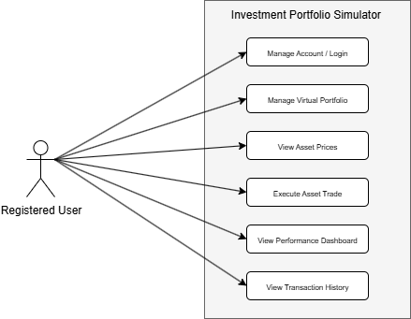
Figure 1. Use case diagram for the Investment Portfolio Simulator

4.3 System requirements
Users require a browser-enabled device and internet access. The application requires a server environment capable of running a web API and relational database. A suitable technology stack is React for the frontend, Node.js with Express for backend services, and MySQL or PostgreSQL for data storage. Supporting tools may include GitHub, Postman, Visual Studio Code, and a charting library.

5. Functional and Non-functional Requirements

5.1 Functional requirements
Requirement | Description
FR1 | The system shall allow users to register and log in using valid credentials.
FR2 | The system shall create and maintain a portfolio linked to each user account.
FR3 | The system shall allow users to buy an asset when sufficient balance is available.
FR4 | The system shall allow users to sell an asset that is currently held in the portfolio.
FR5 | The system shall store each completed transaction with date, price, quantity, and trade type.
FR6 | The system shall retrieve current or simulated market data for supported assets.
FR7 | The system shall generate a dashboard showing portfolio value, cash balance, and asset allocation.
FR8 | The system shall provide a searchable and filterable transaction history view.
FR9 | The system shall provide basic analytical indicators (e.g., price trends or moving averages) to support user decision-making.

5.2 Non-functional requirements
The system must be usable, secure, reliable, and maintainable. Key screens such as login and dashboard loading should respond within an acceptable time under normal conditions. Passwords must be stored securely using hashing rather than plain text, which aligns with current authentication guidance from OWASP and NIST (OWASP, 2025; NIST, 2025). The interface should be clear enough for beginner users, and the architecture should remain modular so that future features can be added without major redesign.

6. System Configuration and Architecture

6.1 Hardware configuration
Development can be completed on standard student laptops with stable internet access. For demonstration, the prototype can run in a local environment or in a cloud environment that supports a Node.js application and relational database.

6.2 Software configuration
The recommended stack is React, Node.js, Express, and MySQL or PostgreSQL. Supporting tools can include GitHub for collaboration, Visual Studio Code for development, Postman for endpoint testing, Chart.js or a similar library for visualisation, and bcrypt for password hashing.

6.3 Proposed architecture
A three-layer architecture is appropriate: a presentation layer for the user interface, an application layer for business logic such as authentication and trade processing, and a data layer for persistent storage. This separation improves maintainability and supports cleaner integration between the frontend, backend, and database. The application layer may include a basic analysis module responsible for processing market data and generating simple indicators for user guidance.
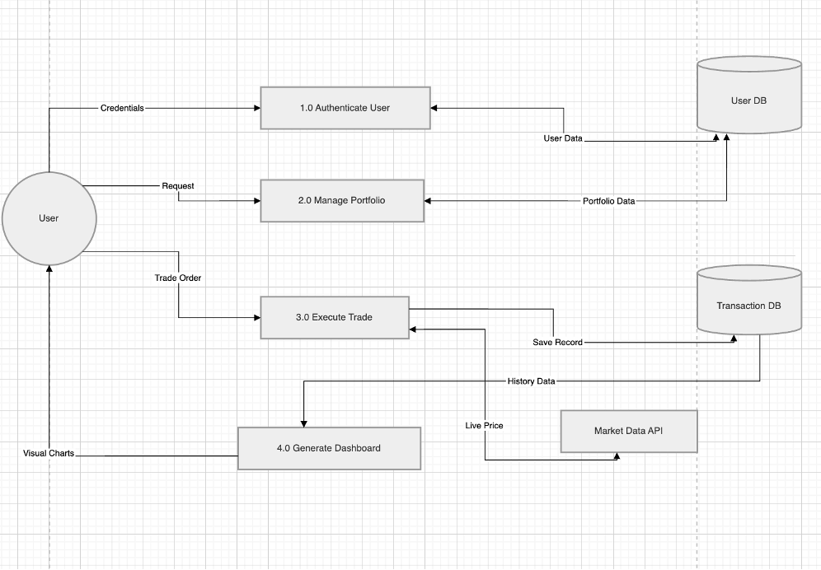
Figure 2. Data flow diagram for the Investment Portfolio Simulator

7. Database Design

7.1 Database requirements
The database must securely store users, portfolios, assets, and transactions. It must support accurate retrieval for dashboard reporting and maintain valid links between related tables so that each portfolio and transaction is correctly associated with a user.

7.2 Entity relationship design
The current ERD uses four main entities: USER, PORTFOLIO, ASSET, and TRANSACTION. This structure is suitable because it separates identity data, portfolio summary data, asset reference data, and trade activity while maintaining referential integrity through foreign keys.
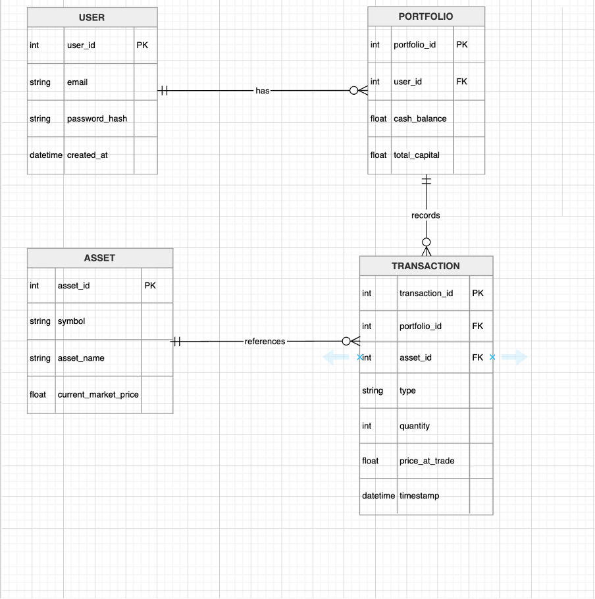
Figure 3. Entity relationship diagram for the core database structure

7.3 Data dictionary
Table | Field | Type | Purpose
USER | user_id | int | Primary key for each user record
USER | email | string | Unique user email used for login
USER | password_hash | string | Hashed password value
PORTFOLIO | portfolio_id | int | Primary key for each portfolio
PORTFOLIO | user_id | int | Foreign key linking portfolio to user
PORTFOLIO | cash_balance | float | Available balance for trading
ASSET | asset_id | int | Primary key for each asset
ASSET | symbol | string | Ticker symbol such as TSLA
TRANSACTION | transaction_id | int | Primary key for each trade
TRANSACTION | type | string | Buy or Sell transaction type
TRANSACTION | quantity | int | Number of units traded
TRANSACTION | timestamp | datetime | Date and time of the trade
TRANSACTION | profit_loss | float | Stroes result of each trade

8. Data Encryption, Anonymization, and Ethical Risk Management

8.1 Data encryption
Although the project is a prototype, the design must still demonstrate secure practice because the assessment brief asks for evidence, not assumptions. Passwords should be hashed with bcrypt before storage, configuration secrets should be kept outside the source code, and HTTPS should be used if the application is deployed online. These controls follow current guidance for authentication and password storage (OWASP, 2025; NIST, 2025).

8.2 Data anonymization
Anonymization is important when screenshots, analytics, or test datasets are shared. User-identifying details such as full email addresses should not appear unnecessarily in charts, screenshots, or demonstration outputs. Generic labels or masked identifiers can be used instead. Data protection by design also supports limiting the exposure of personal data during development and testing (ENISA, 2022).

8.3 Ethical risks and mitigation
The simulator must not be presented as financial advice. A clear disclaimer should state that it is an educational system only. The team must also minimise privacy risk by collecting only essential account data, restricting access between users, and handling sample data responsibly. These measures reduce both technical and ethical risk and support a more credible prototype.

9. Data Protection Impact Assessment (DPIA)

9.1 Purpose
A DPIA helps the team identify privacy risk early and apply privacy-by-design principles during development. This is appropriate for a system that stores account records and transaction-related information.

9.2 Personal data processed
The system processes limited personal data, mainly email address, hashed credentials, account creation date, and portfolio records linked to a user account.

9.3 Key risks and mitigation
The main risks are unauthorised account access, insecure storage of credentials, accidental disclosure during testing, and unnecessary data collection. These risks can be reduced through password hashing, input validation, session control, minimal data collection, secure configuration management, and anonymised outputs during testing and demonstration.

9.4 DPIA conclusion
Overall privacy risk is moderate and manageable for a prototype, provided the stated controls are implemented before demonstration or deployment. A privacy check should also be completed before screenshots or lecturer presentations are shared.

10. User Interface Design

10.1 Design approach
The user interface is designed to be simple, consistent, and suitable for beginner users. The layout aims to reduce clutter, support fast navigation, and present portfolio information in a way that is easy to interpret. The interface is divided into three main components: the dashboard, the trading screen, and the transaction history screen.

10.2 Dashboard interface
The dashboard acts as the main overview page. It presents summary statistics such as total portfolio value, available cash, and recent change, along with visual components such as a line chart for portfolio growth and a pie chart for asset allocation. This supports quick understanding of portfolio position and performance.
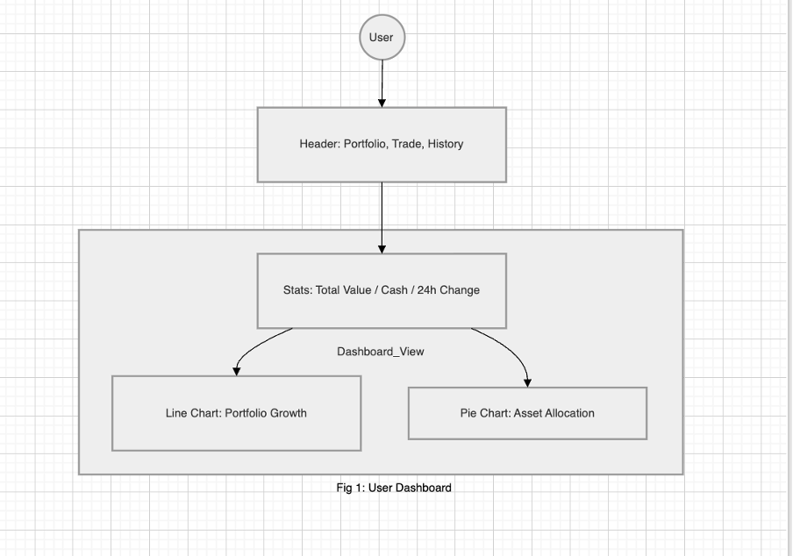
Figure 4. Storyboard of the user dashboard interface

10.3 Trading interface
The trading screen allows users to search for an asset symbol, check live or simulated pricing data, enter a quantity, and execute a buy or sell action. Clear input fields and visible action buttons support ease of use and reduce the chance of user error.
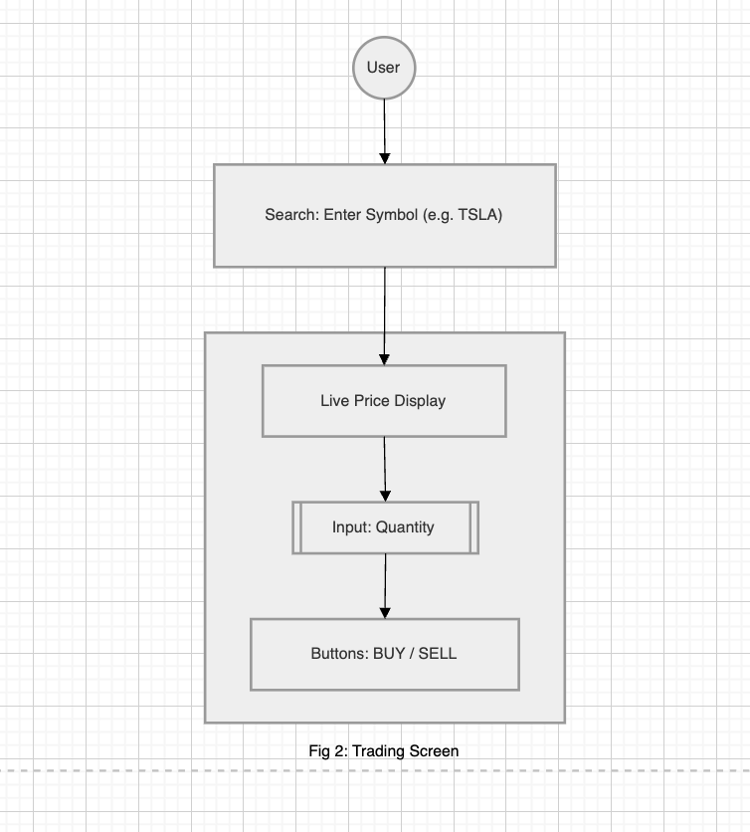
Figure 5. Storyboard of the trading screen

10.4 Transaction history interface
The transaction history screen provides an organised record of completed activity. Filtering by date, asset, or transaction type helps users review past actions and understand their trading pattern over time.
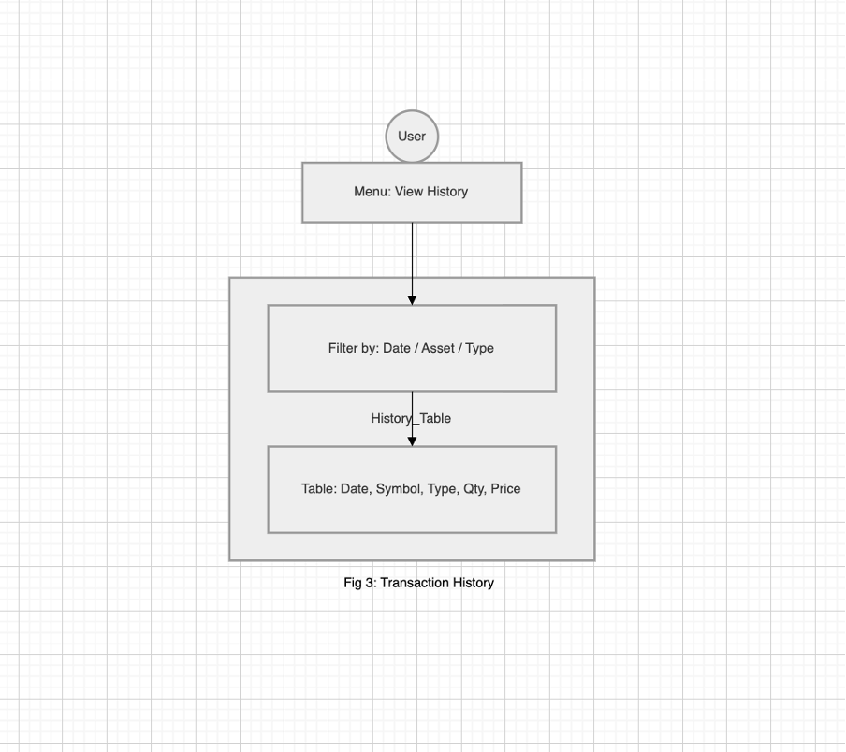
Figure 6. Storyboard of the transaction history screen

10.5 Usability considerations
- Consistency across pages so users do not need to relearn controls.
- Clear labels and beginner-friendly wording.
- Responsive layout for common laptop and mobile screen sizes.
- Minimal number of steps to complete common actions.
- Readable charts and tables to support interpretation rather than confusion.

11. Test Plan and Implementation Plan

11.1 Test plan
Test area | Example scenario | Expected result
Authentication | Login with valid and invalid credentials | Valid users gain access; invalid users receive an error message
Trading logic | Buy asset with sufficient balance | Trade is recorded and cash balance is updated
Trading validation | Buy asset with insufficient balance | Trade is rejected with a clear message
Portfolio update | Sell an asset currently held | Holdings and balance are updated correctly
History and dashboard | Open dashboard and transaction history after trade | Charts and tables reflect the latest saved transaction
Dashboard accuracy | Perform multiple trades | Portfolio value updates correctly

11.2 Implementation plan
Implementation should proceed in stages: set up repositories and database schema; build authentication and backend endpoints; create the frontend pages; integrate market data and charts; perform integrated testing; then prepare the system for demonstration by cleaning test data and checking privacy controls.

12. Work Breakdown Structure and Project Schedule

12.1 Work Breakdown Structure (WBS)
The Work Breakdown Structure divides the project into smaller and manageable components so that tasks can be planned, assigned, and monitored more effectively.
Level 1 | Level 2 | Level 3
1. Project initiation | 1.1 Planning | Define project scope, objectives, and team roles
2. Requirements analysis | 2.1 Requirement gathering | Identify business, user, and system requirements
2. Requirements analysis | 2.2 Documentation | Prepare SRS report and supporting notes
3. System design | 3.1 Architecture design | Prepare architecture, use case, DFD, and ERD
4. Development | 4.1 Backend development | Build APIs, authentication, and business logic
4. Development | 4.2 Frontend development | Create UI pages, charts, and trading screens
5. Integration | 5.1 System integration | Connect frontend, backend, database, and API
6. Testing | 6.1 Testing activities | Complete unit, integration, and user testing
7. Deployment | 7.1 Demonstration readiness | Deploy prototype and prepare final presentation

12.2 Gantt chart
The project timeline follows a 12-week schedule based on the SDLC. The work begins with planning and requirements analysis, moves through design and development, and finishes with testing and deployment. This structure supports balanced workload allocation and makes progress easier to track.
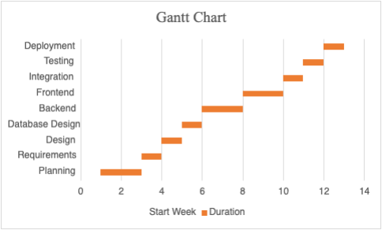
Figure 7. Gantt chart for the Investment Portfolio Simulator project timeline
Week | Phase | Activities
1–2 | Planning and research | Problem analysis, literature review, project planning
3 | Requirements analysis | Define business, user, and system requirements
4 | System design | Prepare architecture, use case, DFD, and ERD
5 | Database and API design | Schema design and endpoint planning
6–7 | Backend development | Implement authentication, logic, and APIs
8–9 | Frontend development | Build UI, dashboard, and trading interface
10 | System integration | Connect frontend, backend, database, and API
11 | Testing | Complete unit, integration, and debugging work
12 | Deployment | Prepare final deployment and demonstration

12.3 Team task allocation
Role | Responsibility
Member 1 | Project coordination, planning, and report integration
Member 2 | Frontend design and user interface implementation
Member 3 | Backend logic, authentication, and API integration
Member 4 | Database design, ERD, and data validation
Member 5 | Testing, quality checking, and documentation support

13. Conclusion

13.1 Summary
This report defines the requirements and design direction for the Investment Portfolio Simulator. The system responds to an authentic educational need by giving beginner users a safe way to practise investment decisions and understand portfolio performance.

13.2 Final evaluation
The project is feasible within the capstone timeframe and the proposed design is aligned with the assessment brief, project proposal, and submitted diagrams. With implementation based on the requirements in this report, the team can produce a secure, user-focused, and academically credible prototype. The inclusion of analytical indicators enhances the educational value of the system and provides users with better insight into market behaviour.

14. References
ENISA (2022) Data protection engineering. European Union Agency for Cybersecurity. Available at: https://www.enisa.europa.eu/publications/data-protection-engineering (Accessed: 12 April 2026).
International Monetary Fund (2024) Promise (un)kept? Fintech and financial inclusion. IMF Working Paper 2024/131. Available at: https://www.imf.org/-/media/files/publications/wp/2024/english/wpiea2024131-print-pdf.pdf (Accessed: 12 April 2026).
NIST (2025) Digital identity guidelines: SP 800-63B. National Institute of Standards and Technology. Available at: https://pages.nist.gov/800-63-4/sp800-63b.html (Accessed: 12 April 2026).
OECD (2023) OECD/INFE 2023 international survey of adult financial literacy. Organisation for Economic Co-operation and Development. Available at: https://www.oecd.org/en/publications/oecd-infe-2023-international-survey-of-adult-financial-literacy_56003a32-en.html (Accessed: 12 April 2026).
OWASP (2025) Authentication cheat sheet. Open Worldwide Application Security Project. Available at: https://cheatsheetseries.owasp.org/cheatsheets/Authentication_Cheat_Sheet.html (Accessed: 12 April 2026).
OWASP (2025) Authorization cheat sheet. Open Worldwide Application Security Project. Available at: https://cheatsheetseries.owasp.org/cheatsheets/Authorization_Cheat_Sheet.html (Accessed: 12 April 2026).
World Bank (2023) Fintech and the future of finance. Washington, DC: World Bank. Available at: https://openknowledge.worldbank.org/entities/publication/b8167e93-e3fb-4d45-a610-a3e774c42f3e (Accessed: 12 April 2026).

Appendix A. Team contribution record
Complete the table below before final submission if your lecturer expects a member-level contribution record.
Member | Primary responsibility | Evidence of contribution
Member 1 | [Insert completed tasks] | [Insert evidence such as files, diagrams, coding, testing, or editing]
Member 2 | [Insert completed tasks] | [Insert evidence such as files, diagrams, coding, testing, or editing]
Member 3 | [Insert completed tasks] | [Insert evidence such as files, diagrams, coding, testing, or editing]
Member 4 | [Insert completed tasks] | [Insert evidence such as files, diagrams, coding, testing, or editing]
Member 5 | [Insert completed tasks] | [Insert evidence such as files, diagrams, coding, testing, or editing]

